## Clone Raspberry Pi

Use Win32 Disk Imager program https://sourceforge.net/projects/win32diskimager/

A Windows tool for writing images to USB sticks or SD/CF card

Finally and most importantly, you need to change the hostname. If it's at its default it's raspberrypi. If you're like me, I ssh to the Raspberry Pi's host name, so I do ssh raspberrypi. Having two "raspberrypis" on the network makes that stop working, so the second one should be renamed to rasberrypi2 for example. You can make this change with sudo raspi-config, selecting Advanced Options, and then selecting Hostname.

## Raspberry PI and GSM modem

documentation: https://www.waveshare.com/wiki/GSM/GPRS/GNSS_HAT

### Connection

via USB on-board jumper set A position – port name ttyUSB0

via UART interface set jumper to B, port name ttyS0 or ttyAMA0

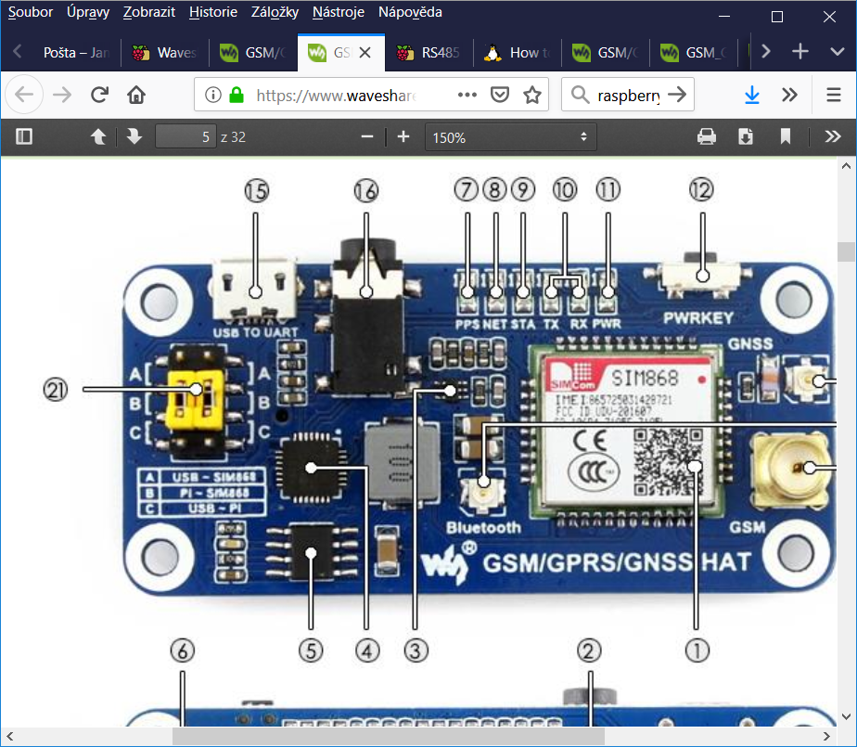

### Software power on SIM module

use python script

import RPi.GPIO as GPIO

import time

GPIO.setmode(GPIO.BOARD)

GPIO.setup(7, GPIO.OUT)

while True:

GPIO.output(7, GPIO.LOW)

time.sleep(2)

GPIO.output(7, GPIO.HIGH)

break

#GPIO.cleanup()#pin must leave set as outpot and not reset to input

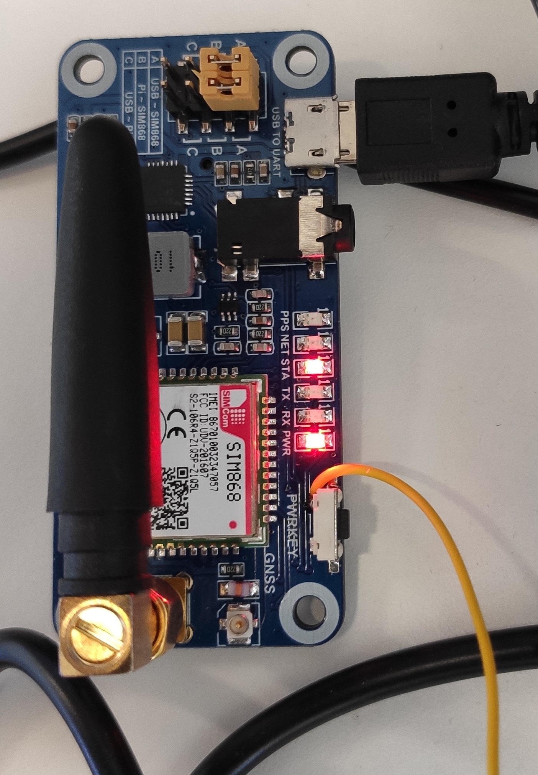

in old version of gsm modem you must connect power switch on GSM board with raspberry PI GPIO4 pin7 (yellow cable) or other unused pin in GPIO. Now is alternatively used GPIO18(pin 12)

set GPIO4 to output after start raspberry

ad line to /boot/config.txt

*gpio=4=op,dh*

set GPIO4 (pin7) to output and high

get GPIO setting

*raspi-gpio get*

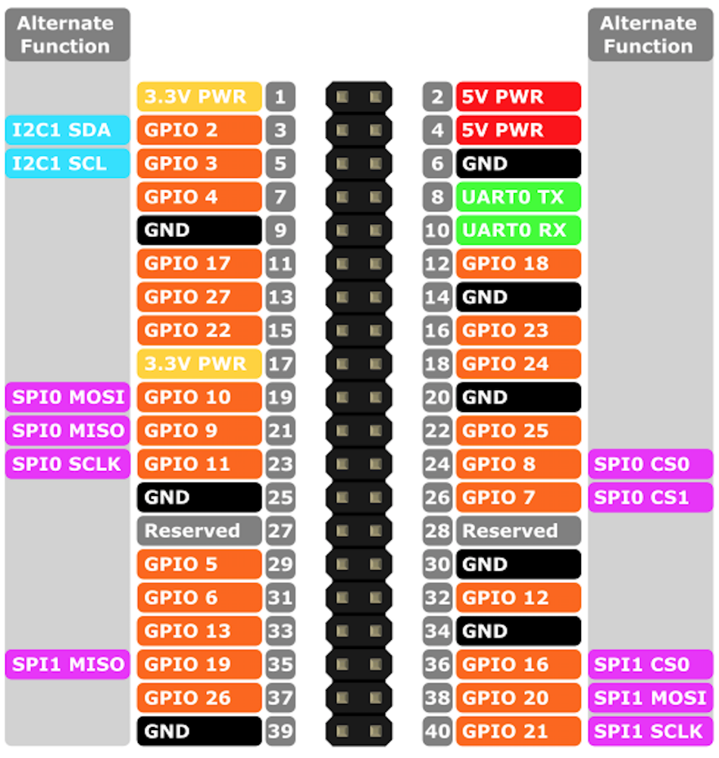

### Config serial port

sudo raspi-config

Choose Interfaces Options->Serial->no->yes. To close serialdebug and enable the hardware serial. Restart your Raspberry Pi

Power on your Raspberry Pi and the SIM module

Manually power on SIM module: Press the PWRKEY button for about 1s

## Test connection to modem Python3 script

#!/usr/bin/python3

# Filename: text.py

import serial

import time

ser = serial.Serial("/dev/ttyS0",115200) #inicialize

W_buff = [b"AT\r\n", b"AT+CMGF=1\r\n"]

print('send data')

print( ser.write(W_buff[0]))

time.sleep(1)

print(ser.read(ser.inWaiting()))

print('finish')

if ser != None:

ser.close()

Response

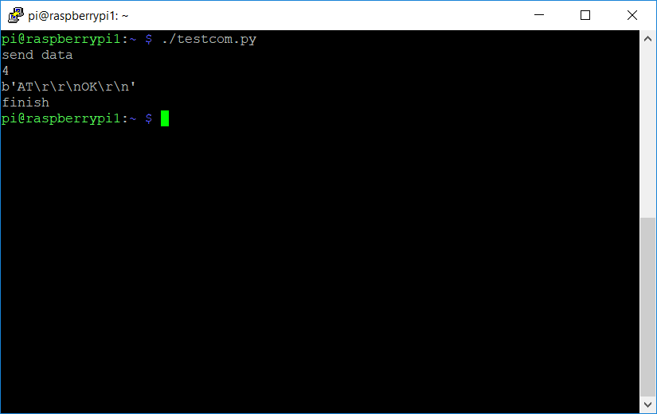

## SEND SMS

#!/usr/bin/python3

# Filename: text.py

import serial

import time

#send sms_text to phone_num

#port is ttyS0 or ttySMS0

def sentSMS(phone_num,SMS_text,port):

ser = serial.Serial("/dev/"+port,115200) #inicializace

W_buff = [b"AT\r\n", b"AT+CMGF=1\r\n", b"AT+CMGS=\""+phone_num.encode()+b"\"\r\n",SMS_text.encode()]

ser.write(W_buff[0])

time.sleep(0.2)

if ser.inWaiting()==0:

return "fail"

data = b""

try:

data += ser.read(ser.inWaiting())

time.sleep(0.1)

data += ser.read(ser.inWaiting())

ser.write(W_buff[1])

time.sleep(0.1)

data += ser.read(ser.inWaiting())

ser.write(W_buff[2])

time.sleep(0.2)

ser.write(W_buff[3])

ser.write(b"\x1a\r\n")# 0x1a : send 0x1b : Cancel send

time.sleep(0.2)

data += ser.read(ser.inWaiting())

except KeyboardInterrupt:

if ser != None:

ser.close()

return "keyb interupt"

return data

if __name__ == '__main__':

d=sentSMS('608643071','test SMS','ttyS0')

print(d)

## Connect to internet via gsm modem

Fistly, we need to install PPP server

*sudo apt-get install ppp*

* Enter the directory /etc/ppp/peers, copy the file provider and name it gprs

*cd /etc/ppp/peers*

*cp provider gprs*

* Open file gprs and edit it
* set name of APN and communication port ttyS0 or ttyUSB0 or ttyAMA0
* tor T-mobile is APN internet.t-mobile.cz and for Vodafone is ‘internet’

#internet.t-mobile.cz is the apn for our connection

connect "/usr/sbin/chat -v -f /etc/chatscripts/gprs -T internet.t-mobile.cz"

# For Raspberry Pi3 use /dev/ttyS0 as the communication port:

/dev/ttyS0

# Baudrate

115200

# Assumes that your IP address is allocated dynamically by the ISP.

noipdefault

# Try to get the name server addresses from the ISP.

usepeerdns

# Use this connection as the default route to the internet.

defaultroute

# Makes PPPD "dial again" when the connection is lost.

persist

# Do not ask the remote to authenticate.

noauth

# No hardware flow control on the serial link with GSM Modem

nocrtscts

# No modem control lines with GSM Modem

local

start ppd

*sudo pppd call gprs*

## stop pppd

*sudo killall pppd*

* Close the network

*~~ifconfig eth0 down~~*

*~~ifconfig wlan0 down~~*

*~~route add -net 0.0.0.0 ppp0~~*

*sudo ip route add default dev ppp0*

Then execute command ifconfig you can find the ppp0

## time synchronizacion

*~~sudo systemctl restart systemd-timesyncd~~*

sudo ntpdate -u tik.cesnet.cz

## ~~test time sync~~

*~~timedatectl~~*

# Raspberry Pi 3 Serial Port Usage

[*https://www.abelectronics.co.uk/kb/article/1035/raspberry-pi-3-and-zero-w-serial-port-usage*](https://www.abelectronics.co.uk/kb/article/1035/raspberry-pi-3-and-zero-w-serial-port-usage)

sudo raspi-config

Select “5 Interfacing Options”

Select “P6 Serial”

Select NO for question „Would you like a login shell to be accessible over serial”

Select YES for question “Would you like the serial port hardware to be enabled”

## Using the PL011 UART port

*in file* /boot/config.txt

*add line*

*dtoverlay=pi3-miniuart-bt*

*and*

*reboot*

*sudo reboot*

*UART is on port* **/dev/ttyAMA0**.

*It should be see when write*

*dmesg | grep tty*

## [~~How to enable CTS RTS for Raspberry Pi 3 b+ UART~~](https://www.raspberrypi.org/forums/viewtopic.php?f=44&t=241623#p1473869)

*~~https://www.raspberrypi.org/forums/viewtopic.php?t=241623~~*

~~in file /boot/config.txt~~

*~~add line~~*

*~~dtoverlay=pi3-miniuart-bt~~*

*~~dtoverlay=uart-ctsrts~~*

~~and copy file~~ [~~https://github.com/HiassofT/AtariSIO/blob/master/contrib/rpi/uart-ctsrts.dtbo~~](https://github.com/HiassofT/AtariSIO/blob/master/contrib/rpi/uart-ctsrts.dtbo)

~~to /boot/overlays~~

## Connection Mencke Irradiance sensor to Raspberry Pi

~~On RS485 board must be pull up and pull down resistors~~

~~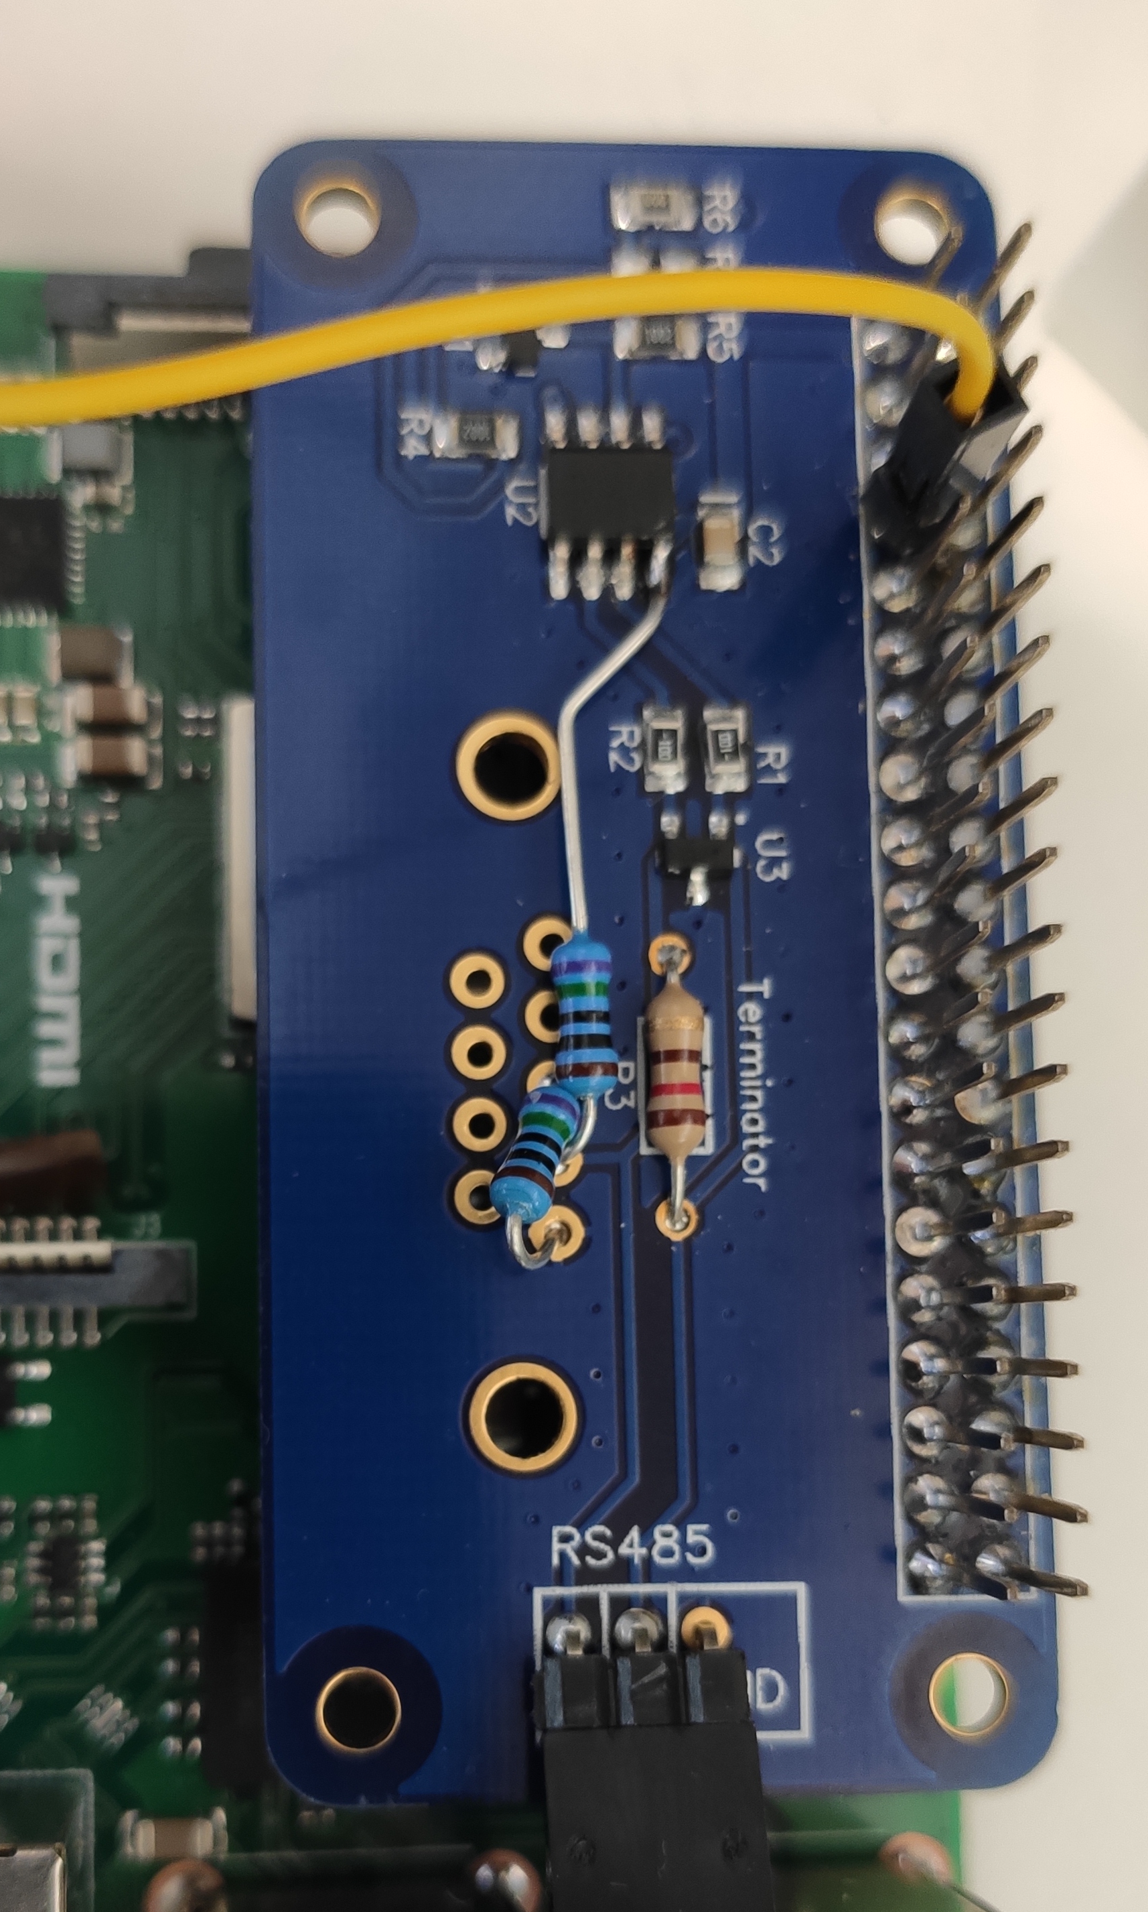~~

irradiance sensor use modbus protocol

<https://www.imt-solar.com/fileadmin/docs/en/products/Specification_Si-RS485_MODBUS.pdf>

First you must configure irradiance sensor and set communication parameters via Si Modbus Configurator <https://www.imt-solar.com/downloads/software/>

~~python test script~~

~~#!/usr/bin/env python3~~

~~import minimalmodbus~~

~~import serial~~

~~def get_data_irradiance(port,address,baudrate ,bytesize ,parity,stopbits ):~~

~~instrument = minimalmodbus.Instrument('/dev/'+port, 11) # port name, slave address (in decimal)~~

~~#instrument.debug = True~~

~~instrument.serial.baudrate = baudrate~~

~~instrument.serial.bytesize = bytesize~~

~~instrument.serial.parity = parity~~

~~instrument.serial.stopbits = stopbits~~

~~instrument.serial.timeout = 0.1 # seconds~~

~~irradinace = instrument.read_register(0,1, 4,False)~~

~~ext_temperature = instrument.read_register(8,1, 4,True)~~

~~cell_temperature =instrument.read_register(7,1, 4,True)~~

~~return irradinace , ext_temperature, cell_temperature~~

~~if __name__ == '__main__':~~

~~irradinace ,ext_temperature,cell_temperature =get_data_irradiance('ttyAMA0',11,19200 ,8,'E',1)~~

~~print ('irrad:', irradinace )~~

~~print ('temp:',ext_temperature)~~

~~print ('cell_temp:',cell_temperature )~~

# Using usb-R485 adapter

use port ttyUSB0

important setting serial.dsrdtr=True

test python script

#!/usr/bin/env python3

import minimalmodbus

import serial

import time

def get_data_irradiance(port,address,baudrate ,bytesize ,parity,stopbits ):

instrument = minimalmodbus.Instrument('/dev/'+port, 11) # port name, slave address (in decimal)

#instrument.debug = True

instrument.serial.baudrate = baudrate

instrument.serial.bytesize = bytesize

instrument.serial.parity = parity

instrument.serial.stopbits = stopbits

#instrument.serial.rtscts= True

instrument.serial.dsrdtr=True

instrument.serial.timeout = 0.1 # seconds

irradinace = instrument.read_register(0,1, 4,False)

ext_temperature = instrument.read_register(8,1, 4,True)

cell_temperature =instrument.read_register(7,1, 4,True)

return irradinace , ext_temperature, cell_temperature

if __name__ == '__main__':

while True:

#try:

irradinace ,ext_temperature,cell_temperature =get_data_irradiance('ttyUSB0',11,19200 ,8,'E',1)

print ('irrad:', irradinace )

print ('temp:',ext_temperature)

print ('cell_temp:',cell_temperature )

#except:

#print('chyba')

time.sleep(3)

# [Auto mount USB stick on plug-in without UUID](https://raspberrypi.stackexchange.com/questions/66169/auto-mount-usb-stick-on-plug-in-without-uuid)

<https://raspberrypi.stackexchange.com/questions/66169/auto-mount-usb-stick-on-plug-in-without-uuid>

### Requirements

1. Install pmount if not installed sudo apt-get install pmount
2. This script mounts drives to /media/usb*, so make sure those folders aren't occupied. **If you want a cleaner look, don't create any folders.**

### Udev rule

1. Create file /etc/udev/rules.d/usbstick.rules
2. Insert:
3. ACTION=="add", KERNEL=="sd[a-z][0-9]", TAG+="systemd", ENV{SYSTEMD_WANTS}="usbstick-handler@%k"
4. Save and close

### Systemd service

1. Create file /lib/systemd/system/usbstick-handler@.service
2. Insert:
3. [Unit]
4. Description=Mount USB sticks
5. BindsTo=dev-%i.device
6. After=dev-%i.device
7. [Service]
8. Type=oneshot
9. RemainAfterExit=yes
10. ExecStart=/usr/local/bin/cpmount /dev/%I
11. ExecStop=/usr/bin/pumount /dev/%I
12. Save and close

### Mount script

1. Create file /usr/local/bin/cpmount
2. Insert:
3. #!/bin/bash
4. if mountpoint -q /media/usb1
5. then
6. if mountpoint -q /media/usb2
7. then
8. if mountpoint -q /media/usb3
9. then
10. if mointpoint -1 /media/usb4
11. then
12. echo "No mountpoints available!"
13. #You can add more if you need
14. else
15. /usr/bin/pmount --umask 000 --noatime -w --sync $1 usb4
16. fi
17. else
18. /usr/bin/pmount --umask 000 --noatime -w --sync $1 usb3
19. fi
20. else
21. /usr/bin/pmount --umask 000 --noatime -w --sync $1 usb2
22. fi
23. else
24. /usr/bin/pmount --umask 000 --noatime -w --sync $1 usb1
25. fi
26. Save and close

### Finish

Reboot your RPi and test.

# Setting access to Fisheye IP camera from Raspberry PI

camera info <http://www.geovision.com.tw/product/GV-FER5701>

Camera is connect via eth0

You must define local ip address of Raspberry PI to same subnet as IP camera

Default IP camera ip address is 192.168.0.10

## Get camera cap_url for config.ini

Connect camera to network or to computer via ethernet cable.

Start the Internet Explorer browser.

Type the IP address or domain name of the camera in the Location/Address field of

your browser.

The default login name and password for Administrator are admin.

**cap_url is address of image in live view in administrators site of camera**

### Set ip adress of raspberry

adds in /etc/dhcpcd.conf:

interface eth0

inform 192.168.0.1

Or you can use GUI interface

## Set route to ip camera

create or edit file

/lib/dhcpcd/dhcpcd-hooks/40-route

and add this line

ip route add 192.168.0.0/24 via 192.168.0.1 dev eth0

## Test route

**Wrong route**

pi@raspberrypi1:~ $ ip route get 192.168.0.10

192.168.0.10 via 10.208.0.1 dev wlan0 src 10.208.255.90

cache

**Correct route**

pi@raspberrypi1:~ $ ip route get 192.168.0.10

192.168.0.10 dev eth0 src 192.168.0.1

cache

### Display route list

pi@raspberrypi1:~ $ ip route list

default via 10.208.0.1 dev wlan0 src 10.208.255.90 metric 303

10.208.0.0/16 dev wlan0 proto kernel scope link src 10.208.255.90 metric 303

192.168.0.0/24 dev eth0 proto kernel scope link src 192.168.0.1 metric 202

# Setting up a Raspberry Pi as an WIFI access point

<https://www.raspberrypi.org/documentation/configuration/wireless/access-point.md>

Install the required software (dnsmasq and hostapd) with this command:

sudo apt install dnsmasq hostapd

Config static IP

add to file

/etc/dhcpcd.conf

Go to the end of the file and edit it so that it looks like the following:

interface wlan0

static ip_address=192.168.4.1/24

nohook wpa_supplicant

Now restart the dhcpcd daemon:

sudo systemctl restart dhcpcd

## Configuring the DHCP server (dnsmasq)

in file /etc/dnsmasq.conf

set this

interface=wlan0

dhcp-range=192.168.4.2,192.168.4.20,255.255.255.0,24h

Reload dnsmasq to use the updated configuration:

sudo systemctl reload dnsmasq

create or edit file

/etc/hostapd/hostapd.conf

interface=wlan0

driver=nl80211

ssid=raspberry

hw_mode=g

channel=7

wmm_enabled=0

macaddr_acl=0

auth_algs=1

ignore_broadcast_ssid=0

wpa=2

wpa_passphrase=skyscanner1

wpa_key_mgmt=WPA-PSK

wpa_pairwise=TKIP

rsn_pairwise=CCMP

We now need to tell the system where to find this configuration file.

sudo nano /etc/default/hostapd

Find the line with #DAEMON_CONF, and replace it with this:

DAEMON_CONF="/etc/hostapd/hostapd.conf"

## Start it up

Now enable and start hostapd:

sudo systemctl unmask hostapd

sudo systemctl enable hostapd

sudo systemctl start hostapd

## Integrate pppd with python script

add row to script /etc/ppp/ip-up

echo "pppd UP" > /tmp/pppipe